**CS223 Preliminary Report**

**2)** Circuit Schematics for the 1-bit Full Adder (above) and 1-bit Full Substractor (below), IC numbers and pin numbers were specified in the first report:

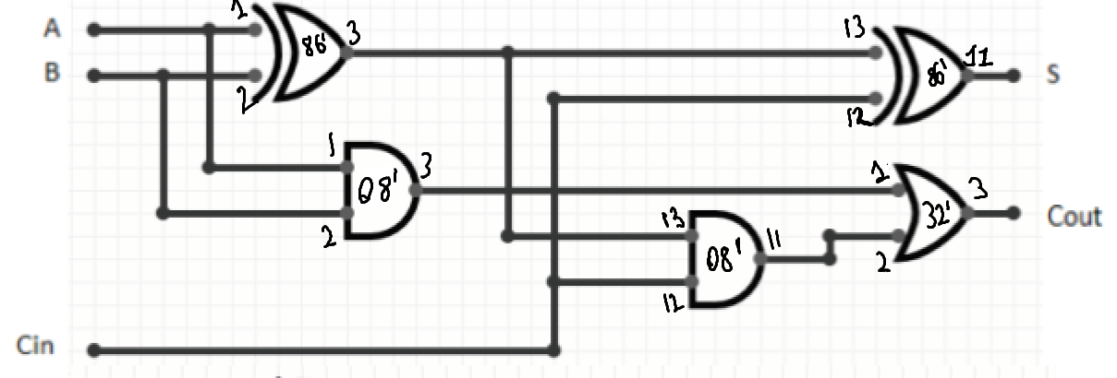

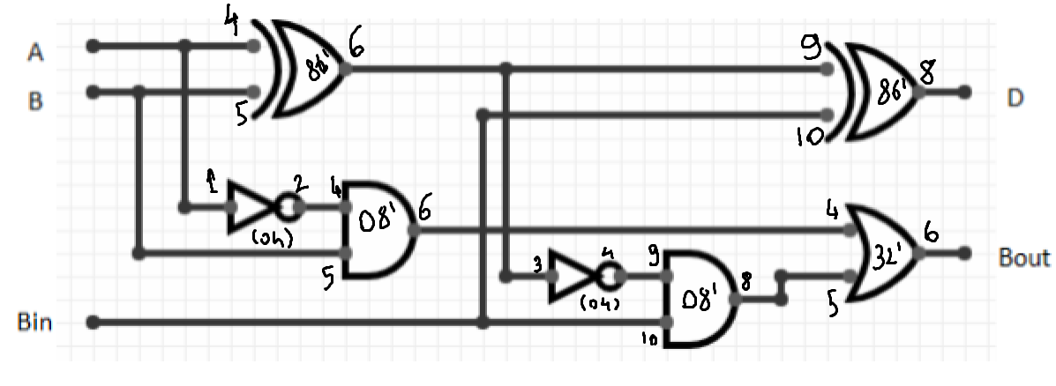

**3)** Schematic for a 2-bit full adder & subtractor made from two 1-bit full adder & subtractors.

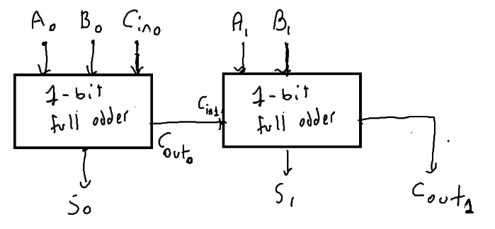

(2-bit full adder schematics)

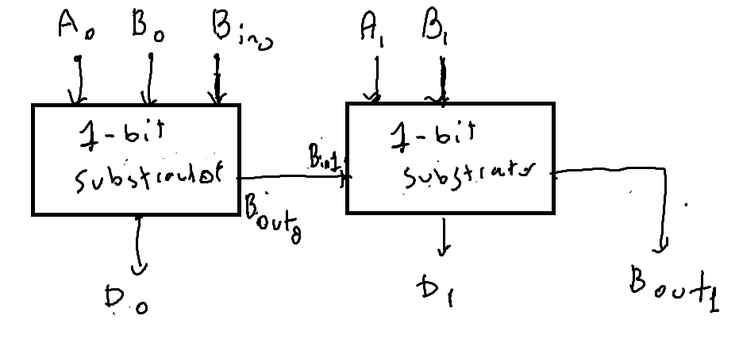

(2 bits substractor schematics)

**4)** Dataflow Systemverilog module for the 1-bit full adder & subtractor.

module b_full_adder(

input logic a, b, c,

output logic sum, carry

);

assign sum = a ^ b ^ c;

assign carry = (a & b) | (c & (a ^ b) );

endmodule

module b_full_substractor(

input logic a, b, B_in,

output logic diff, borrow

);

assign diff = a ^ b ^ B_in;

assign borrow = (~a & B_in) | (~a & b) | (b & B_in);

endmodule

**5)** Structural Systemverilog module for the 1-bit full adder & subtractor and a testbench for

them.

**Note:** half_substractor and half_adder modules are built in order to write structural modules. In case there is a confusion about how they work, their code is also shared.

*

BEHAVIOURAL HALF_ADDER

*/

module half_adder(

input logic a, b,

output logic sum, carry

);

assign sum = a ^ b;

assign carry = a & b;

endmodule

/*

BEHAVIOURAL HALF_SUBSTRACTOR

*/

module half_substractor(

input logic a, b,

output logic diff, borrow

);

assign diff = a ^ b;

assign borrow = b & ~a;

endmodule

/*

STRUCTURAL FULL SUBSTRACTOR

*/

module s_full_substractor(

input a, b, B_in,

output diff, borrow

);

logic d1, b1, b2;

half_substractor Hs1(a, b, d1, b1);

half_substractor Hs2(d1,B_in, diff, b2);

or(borrow, b1, b2);

endmodule

/*

STRUCTURAL FULL ADDER

*/

module s_full_adder(

input a, b, c,

output sum, carry

);

logic s1, c1, c2;

half_adder H1(a, b, s1, c1);

half_adder H2(s1, c, sum, c2);

or(carry, c1, c2);

endmodule

/*

TESTBENCH01

*/

module TestBench01();

logic a, b, c;

logic sum, carry, diff, borrow;

s_full_adder Fa01(a, b, c, sum, carry);

s_full_substractor Fs01(a, b, c, diff, borrow);

// apply inputs one at a time

initial begin

a = 0; b = 0; c = 0; #10;

c = 1; #10;

b = 1; c = 0; #10;

c = 1; #10;

a = 1; b = 0; c = 0; #10;

c = 1; #10;

b = 1; c = 0; #10;

c = 1; #10;

end

endmodule

**6)** Structural Systemverilog module for the 2-bit full adder & subtractor, and a testbench for them.

/*

Structural 2-bit adder

*/

module full_adder_2bit(

input logic a0, a1, b0, b1, c_in,

output logic r0, r1, carry

);

logic c0;

s_full_adder sFa01(a0, b0, c_in, r0, c0);

s_full_adder sFa02(a1, b1, c0, r1, carry);

endmodule

/*

Structural 2-bit substractor

*/

module full_substractor_2bit(

input logic a0, a1, b0, b1,b_in,

output logic r0, r1, borrow

);

logic borrow_0;

s_full_substractor Fs01(a0, b0, b_in, r0, borrow_0);

s_full_substractor Fs02(a1, b1, borrow_0, r1, borrow);

endmodule

/*

TestBench for 2bit substractor and adder

*/

module TestBench02();

logic a0, a1, b0, b1;

logic s0, s1, c, d0, d1, b;

full_adder_2bit Fa(a0, a1, b0, b1, 0, s0, s1, c);

full_substractor_2bit Fs(a0, a1, b0, b1, 0, d0, d1, b);

// apply inputs one at a time

initial begin

a1 = 0; a0 = 0; b1 = 0; b0 = 0; #10; // 00 - 00

b0 = 1; #10; // 00 - 01

b1 = 1; b0 = 0; #10; // 00 - 10

b0 = 1; #10; // 00 - 11

a0 = 1; b1 = 0; b0 = 0; #10; // 01 - 00

b0 = 1; #10; // 01 - 01

b1 = 1; b0 = 0; #10; // 01 - 10

b0 = 1; #10; // 01 - 11

a1 = 1; a0 = 0; b1 = 0; b0 = 0; // 10 - 00

b0 = 1; #10; // 10 - 01

b1 = 1; b0 = 0; #10; // 10 - 10

b0 = 1; #10; // 10 - 11

a0 = 1; b1 = 0; b0 = 0; #10; // 11 - 00

b0 = 1; #10; // 11 - 01

b1 = 1; b0 = 0; #10; // 11 - 10

b0 = 1; #10; // 11 - 11

end

endmodule